

Special Educational Needs and Disabilities (SEND) Information Report
Kingsdown and Ringwould Church of England Primary School
At the heart of our seaside village community, our school celebrates and values the God-given skills and talents of each person, by providing a nurturing environment that promotes deep thinking and curious minds. We strive to raise the aspirations of all, by creating independent and resilient learners, who make an individual and collective difference to our local and global environments.

SEND Governor:
Mrs C Schofield-Myers

SENDCo:
Miss E Cressey Contact No. 01304 373734
senco@kingsdown-ringwould.kent.sch.uk

Interim SENDCo
Mrs Stacey Mitchell (Maternity Cover)
Contact No. 01304 373734
senco@kingsdown-ringwould.kent.sch.uk

Approved by: | LGB | Date: September 2026
Last reviewed on: | November 2025
Next review due by: | November 2027

Contents
- ​What types of SEND does the school provide for? 4
- Which staff will support my child? 5
- ​What should I do if I think my child has SEND? 7
- What happens if the school identifies a need? 8
- ​How will the school measure my child’s progress? 9
- ​How will I be involved in decisions made about my child’s education? 10
- ​How will my child be involved in decisions made about their education? 11
- ​How will the school adapt its teaching for my child? 12
- How will the school evaluate whether the support in place is helping my child? 13
- ​How will the school ensure my child has appropriate resources? 13
- How will the school make sure my child is included in activities alongside pupils who don’t have
SEND? 14
- How does the school make sure the admissions process is fair for pupils with SEN or a disability?
. 15
- How does the school support pupils with disabilities? 15
- How will the school support my child’s mental health and emotional and social development?16
- ​What support is in place for looked-after and previously looked-after children with SEN? 16
- What support will be available for my child as they transition between classes or settings or in preparing for adulthood? 17
- What support is available for me and my family? (Local Offer) 18
- What should I do if I have a complaint about my child’s SEND support? 19
- Supporting Documents 19
- Glossary 20



Dear Parents and Carers,
The aim of this Information Report is to explain how we implement our SEND policy. In other words, we want to show you how SEND support works in our school.
As educational professionals, we are all working towards the ultimate goal of growing independent young people as they prepare for adulthood. All provision and support we provide is working towards achieving the Kent Children and Young People (CYP) Outcomes Framework:
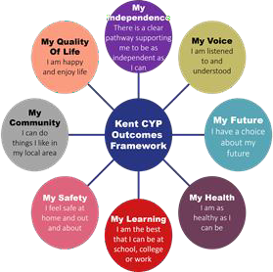
If you want to know more about our arrangements for SEND, read our SEND policy alongside this Information Report.
You can find our SEND policy on our website: https://www.kingsdown-ringwould.kent.sch.uk

Note: If there are any terms we’ve used in this information report that you’re unsure of, you can look
them up in the Glossary at the end of the report.

What types of SEND does the school provide for?

Our school provides for pupils with the following needs (as outlined in the SEND Code of Practice 2015):

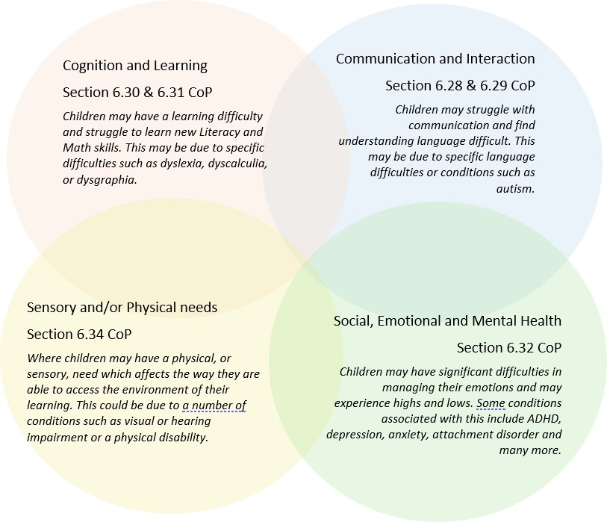

Often you will find that children’s needs overlap and are rarely confined to one area of need, which is why it is important to gain a holistic overview of your child.
More information about the Areas of Need can be found in the Special educational needs and disability code of practice: 0 to 25 years (link below).
SEND_Code_of_Practice_January_2015.pdf (publishing.service.gov.uk)

2. Which staff will support my child, and what are their key responsibilities?

At our school all staff are considered responsible for supporting the needs of pupils with SEND. Our staff are committed to regular, high-quality training to ensure that they have the knowledge and skills to better meet a wide range of pupil needs.
Below outlines key staff who will be supporting your child. Please note that this list is not exhaustive.
Our Special Educational Needs Co-ordinator (SENCO)
Our SENDCo is Miss Emma Cressey. Emma has been working as a SENDCo for 6 years and has the NASENCO (National Award in Special Educational Needs Co-ordination) qualification. Emma qualified as a teacher in 2016. Emma is also a designated safeguarding lead.
Our Interim SENDCo - Stacey has over 20 years’ experience working in a SENCO role and has the NASENCO (National Award in Special Educational Needs Co-ordination) qualification. Stacey qualified as a teacher in 1997. Alongside the SENCO role Stacey has also had the following roles in school: designated safeguarding lead, designated teacher for children in care, key Stage co-ordinator, student and ECT mentor and inclusion lead. She is currently a SEND Governor in two schools in the local area and a specialist dyslexia teacher.
Both Emma and Stacey have a wide range of experience in the support of children with Special Educational Needs and Disabilities. This includes:
Speech, Language and Communication Needs (including autism, all areas of speech and language - developmental language disorder, selective mutism, stammering)
Cognition and Learning (including specific learning difficulties - dyslexia, dyscalculia, developmental co-ordination disorder)
Social Emotional and Mental Health Needs (including trauma, anxiety, ADHD, ODD)
Physical and/Sensory Needs (including visual impairment, hearing impairment, sensory impairment,)

Class/subject teachers

All our teachers receive in-house SEN training, and are supported by the SENCO to meet the needs of pupils who have SEN.

SEND Training provided to staff
2021 - 2022 | Selective Mutism Bereavement Training  De-escalation Techniques Sensory Processing  Lego Therapy Autism in Girls Dyslexia  Emotional Regulation in Children with ASD Precision Teaching  What is Down Syndrome  Anxiety and ASC
September 2022 - 2023 | Working Memory  Making a Difference Training for all Support Staff Annual - Diabetes Training  Ongoing professional development - Nurture UK
September 2023 - 2024 | Supporting ASC and SEMH in the Classroom AET Training  Engagement for Learning Makaton Training  Fizzy Training Clever Hands
September 2024 - 2025 | Safeguarding  Gestalt Training (pre-verbal children)  Type 1 Diabetes  Epilepsy Training
September 2025 – September 2026 | Little Wandle Update training (including SEND pathway)  Attention Autism  Attention Bucket  Suicide awareness and preventing training  Dyslexia Training  Intensive Interaction Training  Transforming Behaviour Through Trauma Informed Approaches  Precision Teaching  Cognitive Behavioural Techniques  Executive Functioning Training  Certificate in Allergy and Anaphylaxis Awareness  Selective Mutism  Drawing and Talking Training  Type 1 Diabetes  Epilepsy Training

Teaching assistants (TAs)
We are very fortunate to have a team of 8 class TAs, a nurture lead and 3 SEND Support TAs.
We have teaching assistants who are trained to deliver interventions such as Fizzy, Clever Hands, Attention Bucket, Precision Teaching, Speech and Language and Sensory Circuits.

External agencies Sometimes we need extra help to offer our pupils the support that they need. Whenever necessary we will work with external support services to meet the needs of our pupils with SEND and to
support their families. These may include:



- Child and young person’s mental health services (CYPMHS)
- Attendance and Inclusion officers (KPAS)
- Educational psychologists (EP)

- GPs and paediatricians
- NELFT practitioners
- Occupational therapists OT)
- Play Therapists
- Safeguarding services
- School Liaison Officer
- Counsellors
- School nurses
- SEND Inclusion Advisor

- Specialist Teachers
- Speech and language therapists (SALT)
- Emotional Wellbeing Team
- Voluntary sector organisations

What should I do if I think my child has SEND?
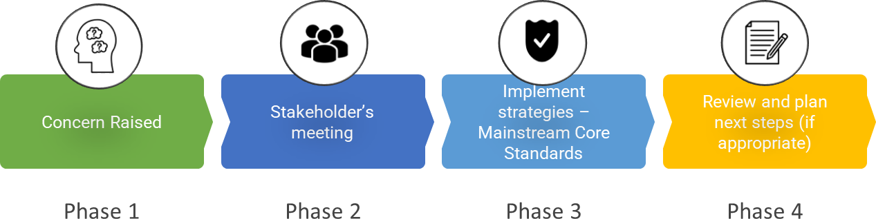

Phase 1 | If you think your child might have SEND, raise your concern with the class teacher so that the SENCO is aware. This can be done through parent consultations or making an appointment through the school office.
Phase 2 | We will meet with you to discuss your concerns and try to get a better understanding of what your child’s strengths and difficulties are. Together we will decide what outcomes to seek for your child and agree on next steps. We will make a note of what’s been discussed and add this to your child’s record.
Phase 3 | We will implement the agreed strategies and monitor these over an agreed period of time. These are likely to be universal strategies set out in the mainstream core standards. A copy of this can be found here: https://www.kelsi.org.uk/ data/assets/pdf_file/0005/117257/Special-educational-needs-mainstream-core-standards-guide-for-parents.pdf . This will initiate the ‘Graduated Approach’ where support will be continually reviewed. See next page for more details.
Phase 4 | If we decide that your child needs SEND support, we will formally notify you and your child will be added to the school’s SEND register. They will receive additional support and this will be reviewed using the assess, plan, do, review model.

What happens if the school identifies a need?
The same process is followed if a concern is raised by the school.

All our class teachers are responsible for the monitoring of all pupils who have been identified as having SEND. They also review those who are not making the expected level of progress in their schoolwork or socially.
If the teacher notices that a pupil is having difficulties, they try to find out if the pupil has any gaps in their learning. If they can find a gap, the school will provide appropriate support. Pupils who don’t have SEND usually make progress quickly once the gap in their learning has been filled.
If the pupil is still finding it difficult to make the expected progress, the teacher will talk to the SENCO, and either the teacher or the SENCO will contact you to discuss the possibility that your child has SEND, and the school will follow the graduated approach (see previous page).

How will the school measure my child’s progress?

We will follow the ‘graduated approach’ to meeting your child’s SEND needs. The graduated approach is a 4-part cycle of assess, plan, do, review.
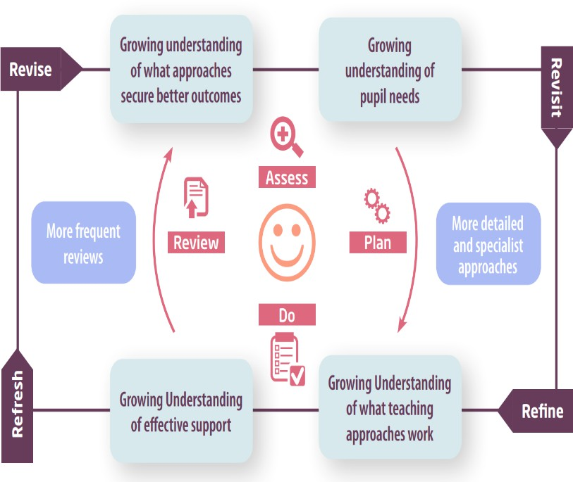

Assess | If your child is not making the expected level of progress, we will complete observations and assessments if appropriate to make an assessment to find out what strengths and difficulties your child has. We will ask for you and your child’s input, as well as getting help from external professionals where necessary.
Plan | In discussion with you and your child, we will decide what outcomes we are hoping to achieve. We will make a plan of the support we will offer your child to help them meet those outcomes. We will make a record of this and share it with you and all relevant  school staff.
Do | We will put our plan into practice.  The class teacher, with the support of the SENCO, will be responsible for working with your child on a daily basis, and making sure the support we put in place is having the impact we intended.
Review | We will assess how well the support we put in place helped the pupil to meet the outcomes we set. We will use our improved understanding of your child’s needs to improve the support we offer; this may mean the Plan, Assess, Do, Review cycle  continues.

How will I be involved in decisions made about my child’s education?

We provide annual reports on your child's progress.
A member of staff who knows your child well will meet you formally three times per year to:
  - Set clear outcomes for your child’s progress
  - Review progress towards those outcomes
  - Discuss the support we will put in place to help your child make that progress
  - Identify what we will do, what we will ask you to do, and what we will ask your child to do
The SENCO may also attend these meetings to provide extra support.
We know that you’re the expert when it comes to your child’s needs and aspirations. So, we want to make sure you have a full understanding of how we’re trying to meet your child’s needs, so that you can provide insight into what you think would work best for your child.
We also want to hear from you as much as possible so that we can build a better picture of how the SEND support we are providing is impacting your child outside of school.
If your child’s needs or aspirations change at any time, please let us know right away so we can keep
our provision as relevant as possible.
If you have concerns that arise between these meetings, please contact the school office and either the class teacher and/or SENCO will arrange an additional meeting.

How will my child be involved in decisions made about their education?

The level of involvement will depend on your child’s age and individual needs. We recognise that no two pupils are the same, so we will decide on a case-by-case basis, with your input.
We may seek your child’s views by asking them to:
  - Attend meetings to discuss their progress and outcomes
  - Prepare a presentation, written statement, video, drawing, etc.
  - Discuss their views with a member of staff who can act as a representative during the meeting
  - Complete a survey/pupil voice questionnaire (adapted according to needs)



How will the school adapt its teaching for my child?
Your child’s teacher is responsible and accountable for the progress and development of all the pupils in their class.
High-quality teaching is our first step in responding to your child’s needs. We will make sure that your
child has access to a broad and balanced curriculum in every year they are at our school.
We will adapt our approaches to how we teach to suit the way the pupil works best. There is no 'one size fits all’ approach to adapting the curriculum, we work on a case-by case basis to make sure the adaptations we make are meaningful to your child and are guided by the Mainstream Core Standards in the first instance.
These adaptations may include:

- Adapting our approaches, for example, giving longer processing times, pre-teaching of key vocabulary, reading instructions aloud, visual, verbal and non-verbal prompting etc


- Adapting our resources and staffing


- Using recommended aids, such as laptops, coloured overlays, visual timetables, larger font, etc.


- Teaching assistants or support staff will support pupils appropriately depending on their presentation of need


- Scaffolding lesson materials

We may also provide the following interventions:

Intervention | Focus | Impact
Language for Thinking | To develop skills of comprehension  and inference based around a specific image/ social scenario. | Children develop their ability to infer and deduce information.
Speech Link | To develop speech sounds. | Children become more successful at  hearing and saying a particular

 |  | speech sound and start to apply it to sound production within words
Language Link | The use and understanding of language. | Children, primarily in Reception class and Year 1 are better able to follow instructions within the class and teaching activities, developing vocabulary and good sentence structure.
Sensory Circuits | Programme to support children to integrate sensory processes to enable them to be more focused for lessons following carefully structured exercise. | Children are better able to enter the classroom in a calm manner, organise themselves and be ready for learning.
Fizzy | Occupational Therapy programme focussing on developing balance, ball skills and spatial awareness. | Children become more confident in using their body in PE and play activities.
Clever Hands | Occupational Therapy programme focussing on developing fine motor skills through strengthening hands  and developing coordination. | Children’s handwriting, cutting and  other fine motor skills improve.
Nurture Support | Emotional Literacy Self-esteem  Social Skills Friendship issues Relationships Managing feelings Anxiety and worries Bullying  Conflict  Emotional Regulation Growth Mindset Problem solving | Children have the opportunity to speak openly and to an adult they feel secure with about how they are feeling and are given strategies to support them.
Precision Teaching  – used for spelling and reading | To support children who are displaying persistent literacy  difficulties | Children have overlearning opportunities that enable them to  embed common exception words.

These interventions are part of our contribution to Kent County Council’s local offer.

How will the school evaluate whether the support in place is helping my child?
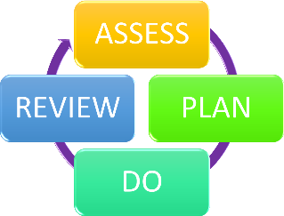
We will evaluate the effectiveness of provision for your child by:
  - Reviewing their progress towards their goals each term
  - Reviewing the impact of interventions after 6 weeks (approximately 1 term)
  - Using pupil questionnaires and pupil voice
  - Monitoring by the SENCO
  - Using provision plans to measure progress
  - Discuss each child in Pupil Progress Meetings (held with Headteacher, Class teacher and SENCO)
  - Holding an annual review (if they have an education, health and care (EHC) plan)

How will the school ensure my child has appropriate resources?
It may be that your child’s needs mean we need to provide additional resources such as:
- Additional resources to support their learning
- Adaptations to in-class support
- Further training for our staff
- External specialist expertise
Where appropriate, we will consult with external agencies to get recommendations on what will best help your child access their learning and use our best endeavours to ensure these are supplied.
As part of our budget, we receive ‘notional SEN funding’. This funding is used to ensure that the quality of teaching is good in the school. It is also used to provide additional and different provision for pupils requiring SEND support. The amount of support required for each pupil to make good progress will be different in each case and designed to meet the child’s needs.


11. How will the school make sure my child is included in activities alongside pupils
who don’t have SEND?

Our aim is to provide inclusive provision for all pupils. It may be necessary for some pupils to receive interventions in addition to a broad and balanced curriculum.
All our extra-curricular activities and school visits are available to all our pupils, including our before and after-school clubs. All pupils are encouraged to go on our school trips, including residential trips.
All pupils are encouraged to take part in our activity days, visits to the church, local swimming pool/sports club, sports day, school productions and special workshops.
No pupil is ever excluded from taking part in these activities because of their SEN or disability and we will make reasonable adjustments are needed to make sure that they can be included.

12. How does the school make sure the admissions process is fair for pupils with SEN or a disability?

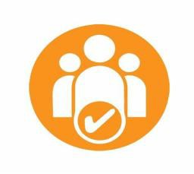
The admission of children to the school will be decided by an Admissions Panel which is constituted as defined in the School and Community Policy. Admissions will be based on the number of places available and our admission criteria.
  - Before the application of oversubscription criteria, children with an Education, Health and Care Plan (EHCP) which names the school will be admitted. Consequently, the published admissions number will be reduced accordingly.
  - If the school is oversubscribed, applications are considered by the Admissions Panel, consisting of members from the school’s Full Governing Body. School

places will be allocated in line with order of priorities (see our full Admissions Policy) and in line with the LEA co-ordinated scheme. Any parents/carers who are refused the offer of a school place for their child have the right of appeal and should in the first instance write to the Chair of the Governing Body (via the School Office) requesting that an independent appeal be heard.

How does the school support pupils with disabilities?

Equality Act 2010:
The definition is set out in section 6 of the Equality Act 2010. It says you're disabled if: you have a physical or mental impairment. your impairment has a substantial and long-term adverse effect on your ability to do normal day-to-day activities.
All children are included in all activities wherever possible we will work closely with parents and outside agencies to ensure our best endeavours. This may mean that some special arrangements and/or equipment will be put in place, or a risk assessment carried out beforehand.
All school clubs and activities are made available to all pupils and suitable adjustments will be made to support all pupils.
Our school is always looking at ways to improve the school environment by making it more accessible to pupils, parents and visitors. This allows pupils to become more
independent. Our building is all at ground level and where external advisors recommend the use of equipment or facilities which the school does not have, we will purchase it using the notional SEN funding, or seek it by loan. For highly specialist communication equipment the school will seek the advice of the KCC Communication and Assistive Technology Team.
Please see our school’s Accessibility Plan
14. How will the school support my child’s mental health and emotional and social development?
We provide support for children to progress in their emotional and social development in the following ways:

  - We provide extra pastoral support for listening to the views of pupils with SEND by completing pupil voice questionnaires and always listening to their views through informal discussions in whole class, group and individually.
  - At our school we run a range of interventions to support pupils with social skills, behaviour management and emotional wellbeing:
    - Time with our nurture lead
    - Daily Check Ins or ‘Walk and Talks’
    - Time with specific adults within the school
    - Friendship Programmes
    - We use the Boxall Profile to plan and provide strategies and programmes at a class, group or individual level.
  - We have a ‘zero tolerance’ approach to bullying. Our school ethos:
Our school community recognises that all forms of bullying, especially if left unaddressed, can have a devastating effect on individuals; it can create a barrier to learning and have serious consequences for mental wellbeing.
By effectively preventing and tackling bullying our school can help to create a safe and disciplined environment, where pupils are able to learn and fulfil their potential.
Please see our school Anti Bullying Policy

If you are concerned about your child’s emotional wellbeing, please speak to their class teacher or
the SENCO.

15. What support is in place for looked-after and previously looked-after children with SEND?

Jo Hygate is the designated teacher for looked-after children and previously looked-after children.
Jo Hygate will work with Miss Cressey, our SENCO, to make sure that all teachers understand how a looked-after or previously looked-after pupil’s circumstances and their SEND might interact, and what the implications are for teaching and learning.

Pupils who are looked-after or previously looked-after will be supported much in the same way as any other child who has SEND. However, looked-after pupils will also have a personal education plan (PEP). We will make sure that the PEP and any SEND support plans or EHC plans are consistent and complement one another.

16. What support will be available for my child as they transition between classes or settings or in preparing for adulthood?

Between years
To help children with SEND be prepared for a new school year we:

  - The current teacher and the new teacher will meet and discuss effective strategies and resources and the child’s strengths and difficulties. The new teacher will attend a parent SEND review meeting with the SENCO at the end of the school year.
  - Sessions will be timetabled with the incoming teacher towards the end of the summer term.
  - Children will complete transition booklets for their new class teacher.
  - Children will have scheduled visits to their new classroom

Between schools
When your child is moving on from our school, we will ask you and your child what information you want us to share with the new setting.

Primary to secondary transition
The SENDCo of the secondary school will meet with our SENCO during the local Secondary Transition Meetings, they will discuss the needs of all the pupils who are receiving SEND support. We often organise parent meetings with the school’s SENCO and/or additional visits will be organised if appropriate for the child.
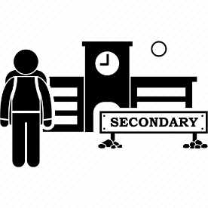
Pupils will be prepared for the transition by:
  - Practising new skills, for example using a secondary school timetable
  - Learning how to get organised independently
  - Following a structured SEND Transition Programme

Transition from nursery to our school:
Our reception staff provide a package that is organised to promote a successful transition for all children starting at our school. We support a smooth transition to Reception class by offering settling in sessions, family visits and through the use of social stories which all children have access to.

The Reception class teacher and SENCO take part in a handover day where Nursery settings are met with to gain key handover information.
The SENCO will contact nurseries about key pupils who may need additional support when they start school in September.

What support is available for me and my family?
If you have questions about SEND, or are struggling to cope, please get in touch to let us know. We want to support you, your child and your family.
To see what support is available to you locally, have a look at Kent’s local offer. Kent publishes information about the local offer on their website:
https://www.kent.gov.uk/education-and-children/special-educational-needs/about-the-send-local-offer

Our local special educational needs and disabilities information advice and support services (IASK) organisation:
https://www.kent.gov.uk/education-and-children/special-educational-needs/listening-to-your-voice-and-taking-action/Information-Advice-and-Support-Kent

Local charities and support groups that offer information and support to families of pupils with SEND are:
https://local.kent.gov.uk/kb5/kent/directory/service.page?id=qwAub156n5E&youthchannel=1 (KCC Youth Services, Linwood Hub)
https://www.forustoo.org/ For Us Too https://www.includesus2.org.uk/ Includes Us 2
https://www.kent.gov.uk/education-and-children/special-educational-needs/listening-to-your-voice-and-taking-action/kent-pact Kent Parent and Carers Together
https://wonderful.org/charities/299301 Pegasus Playscheme for neurodiverse children
https://www.dover.gov.uk/Community/Grants-Funding/Inspire-Project/Inspire-Project.aspx Inspire Project (activities and clubs for children with SEND)
National charities that offer information and support to families of pupils with SEND are:
- IPSEA
- SEND family support
- NSPCC
- Family Action
- Special Needs Jungle

What should I do if I have a complaint about my child’s SEND support?

We highly encourage parents to speak to the child’s class teacher/SENCO or Headteacher if ever they are unsatisfied with arrangements for their child. This allows us the chance to listen to all involved (including the child) and the opportunity to make changes or put things right. However, if at any time you have a complaint about the provision your child is receiving, please refer to the school complaints procedure policy on our school website.
https://www.kingsdown-ringwould.kent.sch.uk/Policies/

If you are not satisfied with the school’s response, you can escalate the complaint. In some
circumstances, this right also applies to the pupil themselves.
To see a full explanation of suitable avenues for complaint, see pages 246 and 247 of the SEND Code of Practice.
If you feel that our school discriminated against your child because of their SEND, you have the right to make a discrimination claim to the first-tier SEND tribunal. To find out how to make such a claim, you should visit: https://www.gov.uk/complain-about-school/disability-discrimination
You can make a claim about alleged discrimination regarding:
- Admission
- Exclusion
- Provision of education and associated services
- Making reasonable adjustments, including the provision of auxiliary aids and services
Before going to a SEND tribunal, you can go through processes called disagreement resolution or mediation, where you try to resolve your disagreement before it reaches the tribunal.
https://www.globalmediation.co.uk/service/special-educational-needs-disability/

Supporting documents
  - Equality Policy

  - Child protection and safeguarding policy
  - Behaviour Policy
  - Accessibility Plan
  - Attendance Policy
  - SEND Policy
  - SEN & Disabilities Code Of Practice 2015
  - Mainstream Core Standards

Glossary
- Access arrangements – special arrangements to allow pupils with SEND to access assessments or exams
- Annual review – an annual meeting to review the provision in a pupil’s EHC plan
- Area of need – the 4 areas of need describe different types of needs a pupil with SEND can have. The 4 areas are communication and interaction; cognition and learning; physical and/or sensory; and social, emotional and mental health needs.
- CAMHS – child and adolescent mental health services/CYPMHS – child and young person’s mental health services
- Differentiation – when teachers adapt how they teach in response to a pupil’s needs
- EHC needs assessment – the needs assessment is the first step on the way to securing an EHC plan. The local authority will do an assessment to decide whether a child needs an EHC plan.
- EHC plan – an education, health and care plan is a legally-binding document that sets out a child’s needs and the provision that will be put in place to meet their needs.
- First-tier tribunal/SEND tribunal – a court where you can appeal against the local authority’s decisions about EHC needs assessments or plans and against discrimination by a school or local authority due to SEND
- Graduated approach – an approach to providing SEND support in which the school provides support in successive cycles of assessing the pupil’s needs, planning the provision, implementing the plan, and reviewing the impact of the action on the pupil
- Intervention – a short-term, targeted approach to teaching a pupil with a specific outcome in mind
- Local offer – information provided by the local authority which explains what services and support are on offer for pupils with SEND in the local area
- Outcome – target for improvement for pupils with SEND. These targets don't necessarily have to be related to academic attainment
- Reasonable adjustments – changes that the school must make to remove or
reduce any disadvantages caused by a child’s disability
- SENCO – the special educational needs co-ordinator
- SEN – special educational needs
- SEND – special educational needs and disabilities
- SEND Code of Practice – the statutory guidance that schools must follow to support pupils with SEND
- SEND information report – a report that schools must publish on their website, that explains how the school supports pupils with SEND
- SEND support – special educational provision which meets the needs of pupils with SEND
- Transition – when a pupil moves between years, phases, schools or institutions or life stages



