School Uniform Policy
Kingsdown and Ringwould CEP School
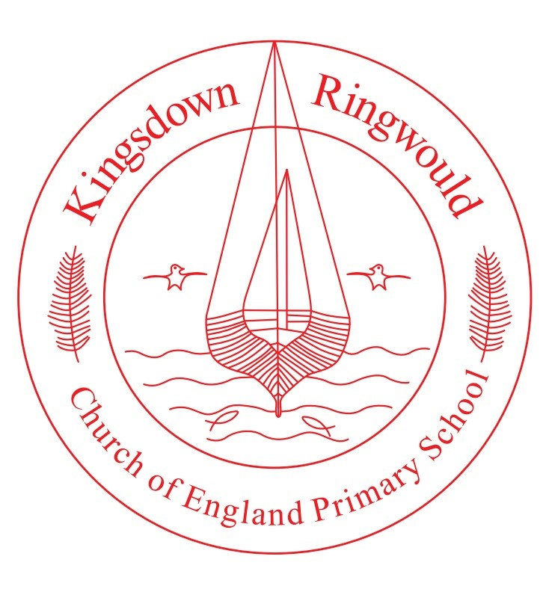

At the heart of our seaside village community, our school celebrates and values the God-given skills and talents of each person, by providing a nurturing environment that promotes deep thinking and curious minds. We strive to raise the aspirations of all, by creating independent and resilient learners, who make an individual and collective difference to our local and global environments.
Our vision and values are guided by the Bible story of Jesus healing the paralysed man (Mark 2: 1–12).

Approved by: | Local Governing Body | Date: September 2022
Last reviewed on: | September 2026
Next review due by: | September 2028

Contents
1. Aims 3
2. Our school’s legal duties under the Equality Act 2010 3
3. Limiting the cost of school uniform 3
4. Expectations for school uniform 4
5. Expectations for our school community 5
6. Monitoring arrangements 6
7. Links to other policies 6

1. Aims
This policy aims to:
- Set out our approach to requiring a uniform that is of reasonable cost and offers the best value for money for parents and carers.
- Explain how we will avoid discrimination in line with our legal duties under the Equality Act 2010.
- Clarify our expectations for school uniform.

2. Our school’s legal duties under the Equality Act 2010
The Equality Act 2010 prohibits discrimination against an individual based on the protected characteristics, which include sex, race, religion or belief, and gender reassignment.
To avoid discrimination, our school will:
- Avoid listing uniform items based on sex, to give all pupils the opportunity to wear the uniform they feel most comfortable in or that most reflects their self-identified gender.
- Make sure that our uniform costs the same for all pupils.
- Allow all pupils to have long hair (though we reserve the right to ask for this to be tied back)
- Allow all pupils to style their hair in a way that is appropriate for school yet makes them feel most comfortable.
- Allow pupils to request changes to swimwear for religious reasons.
- Allow pupils to wear headscarves and other religious or cultural symbols.
- Allow for adaptations to our policy on the grounds of equality by asking pupils or their parents to get in touch with Mrs Jo Hygate, who can answer questions about the policy and respond to any requests.

3. Limiting the cost of school uniform
Our school has a duty to make sure that the uniform we require is affordable, in line with statutory guidance from the Department for Education on the cost of school uniforms.
We understand that items with distinctive characteristics (such as branded items, or items that have to have a school logo or a unique fabric/colour /design) cannot be purchased from a wide range of retailers and that requiring many such items limits parents’ ability to ‘shop around’ for a low price.
We will make sure our uniform:
- Is available at a reasonable cost.
- Provides the best value for money for parents/carers.
We will do this by:
- Carefully considering whether any items with distinctive characteristics are necessary.
- Limiting any items with distinctive characteristics where possible.
- Limiting items with distinctive characteristics to low-cost or long-lasting items.
- Considering cheaper alternatives to school-branded items, such as logos that can be ironed on, as long as this doesn’t compromise quality and durability.
- Avoiding specific requirements for items pupils could wear on non-school days, such as coats, bags and shoes.
- Keeping the number of optional branded items to a minimum, so that the school’s uniform can act as a social leveler.
- Avoiding different uniform requirements for different year/class.
- Avoiding different uniform requirements for extra-curricular activities.
- Considering alternative methods for signaling differences in groups for interschool competitions, such as creating posters or labels.
- Making sure that arrangements are in place for parents to acquire second-hand uniform items. We do this through our nearly new uniform system.
- Avoiding frequent changes to uniform specifications and minimising the financial impact on parents of any changes.
- Consulting with parents and pupils on any proposed significant changes to the uniform policy and carefully considering any complaints about the policy.

4. Expectations for school uniform
4.1 Our school’s uniform
We expect all children to wear school uniform and the items suggested have been chosen for comfort, smartness and ease of care.
- The school colours are red, grey, white and black.
- The children should bring a coat to school each day.
Boys
- Grey/black trousers, short or long
- White shirt or polo shirt
- Red polo shirt
- Red school logo fleece/ sweatshirt
- Grey cardigan
- Smart black shoes

Girls
- Grey/black school trousers
- Grey skirt or pinafore
- Grey/red cardigan
- School logo fleece/ sweatshirt
- White blouse or polo shirt
- Red & white check summer dress
- Plain or school colour tights
- Smart black shoes

PE kit
- House colour T-shirt (You will be allocated the colour on entry to school roll)
- Shorts-black/blue
- Plimsolls or trainers
- A tracksuit is useful on cold winter days. (plain- and a dark coloured)
- Football boots (Juniors only).
- A red zipped hoodie is available to buy for PE days

For health and safety reasons, we kindly ask that jewellery is not worn, apart from small stud earrings and simple watches.

4.2 Where to purchase it
Fleeces, sweatshirts, coats, cardigans, PE T-shirts, with the school logo are available from School Trends
Order the Uniform online, and it will be delivered to your home.
We request that all items of clothing are labelled, so we can return misplaced clothing to your child.
We also offer a nearly new uniform sale on the regular basis for a donation to the school charity.

5. Expectations for our school community
5.1 Pupils
Pupils are expected to wear the correct uniform at all times (other than specified non-school uniform days) while:
- On the school premises.
- Travelling to and from school.
- At out-of-school events or on trips that are organised by the school, or where they are representing the school (if required).
Pupils are also expected to contact Mrs Jo Hygate if they want to request an amendment to the uniform policy in relation to their protected characteristics.
5.2 Parents and carers
Parents and carers are expected to make sure their child has the correct uniform and PE kit, and that every item is:
- Clean
- Clearly labelled with the child’s name
- In good condition
Parents are also expected to contact Mrs Jo Hygate if they want to request an amendment to the uniform policy in relation to:
- Their child’s protected characteristics
- The cost of the uniform
Parents are expected to lodge any complaints or objections relating to the school uniform in a timely and reasonable manner.
Disputes about the cost of the school uniform will be:
- Resolved locally
- Dealt with in accordance with our school’s complaints policy
The school will work closely with parents to arrive at a mutually acceptable outcome.
5.3 Staff
Staff will closely monitor pupils to make sure they are in correct uniform. They will give any pupils and families breaching the uniform policy the opportunity to comply but will follow up with the headteacher if the situation doesn’t improve.
In cases where it is suspected that financial hardship has resulted in a pupil not complying with this uniform policy, staff will take a mindful and considerate approach to resolving the situation.
5.4 Governors
The local governing board will review this policy and make sure that it:
- Is appropriate for our school’s context
- Is implemented fairly across the school
- Takes into account the views of parents and pupils
- Offers a uniform that is appropriate, practical and safe for all pupils
The board will also make sure that the school’s uniform supplier arrangements give the highest priority to cost and value for money, for example by avoiding single supplier contracts and by re-tendering contracts at least every 5 years.

6. Monitoring arrangements
This policy will be reviewed every two years by the Senior Leadership Team. At every review, it will be approved by [the full governing board.

7. Links to other policies
This policy is linked to our:
- Behaviour policy
- Equality information and objectives statement
- Anti-bullying policy
- Complaints policy

